A

Project Phase - II Report On

**“CampusConnect”**

Submitted in partial fulfillment of the requirements for

the Degree of

### BACHELOR OF TECHNOLOGY SEMESTER - VIII

**In**

## Computer Science and Engineering

SUBMITTED BY

#### Mr. Katkar Rushikesh Anil Mr. Ghadge Shubham Popat Mr. Dhumal Nishant Vitthal

Under the Supervision of

## C:\Users\vishnu\Downloads\jgp final logo.jpgMr. Pathak P. A.

Department of Computer Science and Engineering

## ARVIND GAVALI COLLEGE OF ENGINEERING, SATARA

**2023-24**

Certificate

This is to certify that the Project report entitled **“CampusConnect: A Student Placement Hub”** is a bonafide work carried out by:

Mr. Katkar Rushikesh Anil Mr. Ghadge Shubham Popat Mr. Dhumal Nishant Vitthal

Under our supervision, during the year 2023-24 and submitted to the faculty of Computer Science and Engineering, AGCE Satara in partial fulfillment of the requirements for the award of the Degree of Bachelor of Technology in Computer Science and Engineering.

Mr.Amol Barge Mr.Pathak P.A Mr.Gujar V.B.

(Alumni Mentor) (Project Guide) (Project Co-ordinator)

Prof. Dr. Bhosale V. K. Dr. Mirajkar G.S. Dr. Pharande.V

(HOD) (Dean R&D) (Principal)

Internal Examiner External Examiner

**UNDERTAKING**

We hereby declare that the details furnished above are true and correct to the best of our knowledge and belief and we undertake to inform authorities about any changes therein, immediately. In case any of the above information is found to be false or untrue or misleading or misrepresenting, we are aware that we may be held liable for it.

|  |  |  |  |
| --- | --- | --- | --- |
| **Sr. No.** | **Name of Student** | **Prn No** | **Sign** |
| 01 | Mr. Katkar Rushikesh Anil | 2065451242034 |  |
| 02 | Mr. Ghadge Shubham Popat | 2065451242044 |  |
| 03 | Mr. Dhumal Nishant Vitthal | 2065451242022 |  |

Place: Satara Date:

**Acknowledgement**

It is our privilege to acknowledge my deep sense of gratitude to my guide Mr. Pathak P.A. in Computer Science and Engineering at Arvind Gavali College of Engineering, Satara for his/her valuable suggestions and guidance throughout our course and the timely help given to us in completion of our project work.

We are thankful to Dr. V. A. Pharande, Principal, Arvind Gavali College of Engineering, Satara and Dr. Bhosale Versha Head of Computer Science and Engineering department for their kind co- operation & moral support.

Finally, we wish to express our sincere thanks to all the staff members of Arvind Gavali College of Engineering, Satara for their direct and indirect help during the course of our project.

##### Date:

**Place: Satara**

## ABSTRACT

Nowadays, whenever a student are completed their degree in engineering or other then he/she have to identify that in which company they can approach according to the different criteria’s of companies.

Student have to check criteria’s of every company to check whether they can apply for the job or no. Students who are trying for off campus placement have these as a big issue in market.

For that we in traduce our website name as “Campus Connect” which identifies the companies for students according the different criteria’s of company.

This is also helpful for students who are prepare for placement in next upcoming year and also for different degree level and wide verities of technical area. One’s a student build their profile then he/she get the list of company in their profile with the company career page link for approaching for placement.

And also student directly enter their information to get result as company name with the career page link on our main page of website.

The platform also benefits companies and Training & Placement Officers (TPOs). Companies can post new vacancies and update criteria, reaching a targeted pool of qualified candidates and receiving application notifications.

TPOs can manage and monitor placement activities, track student applications, and stay informed about new job opportunities, ensuring effective communication between students, companies, and placement officers. Campus Connect aims to streamline the placement process, enhancing the efficiency and connectivity of job searching for students and recruitment for companies.

|  |  |
| --- | --- |
| **CONTENTS** | |
| ABSTRACT | i |
| CONTENTS | ii |
| LIST OF FIGURES | iii |

### CHAPTERS Page No

##### INTRODUCTION

* 1. General introduction 10
  2. Problem Statement 11
  3. Objectives of the present work 12

1. LITERATURE REVIEW
   1. Literature review 14

(Carried out for minimum 5 papers from peer-reviewed journals or reputed conferences)

1. HARDWARE IMPLEMENTATION
   1. Hardware used 17
2. SOFTWARE IMPLEMENTATION
   1. Architecture 18
   2. Flowchart 20
   3. Entity Relationship Diagram 22
   4. Sequence Diagram 23
   5. Class Diagram 25
   6. Use case Diagram 26
   7. Activity Diagram 27
   8. Component Diagram 29
   9. Programming Language Used 30
3. **RESULT AND CONCLUSION**

|  |  |  |
| --- | --- | --- |
| 1.8 | Result | 32 |
| 1.9 | Conclusion | 35 |
| 1.10 | Future Scope | 36 |

##### REFERENCES

1.11 Research Papers 37

**LIST OF FIGURES**

|  |  |  |
| --- | --- | --- |
| **Figure No.** | **Caption** | **Page No.** |
| 4.1 | Architecture | 18 |
| 4.2 | Flowchart | 20 |
| 4.3 | Entity Relationship Diagram | 22 |
| 4.4 | Sequence Diagram | 23 |
| 4.5 | Class Diagram | 25 |
| 4.6 | Use Case Diagram | 26 |
| 4.7 | Activity Diagram | 27 |
| 4.8 | Component Diagram | 29 |

# Chapter 1 INTRODUCTION

## Chapter 1 INTRODUCTION

### 1.1 General Introduction

Campus Connect is a platform designed to help users identify companies where they can apply based on their interests and placement criteria. Users can search for companies aligned with their interests and obtain detailed information about each company's placement criteria. The platform matches users' skills and experience with available job opportunities, providing a tailored list of companies with relevant job openings.

The platform offers two types of logins: one for students and another for college Training & Placement Officers (TPOs). Administrators can view student information and profiles, and they can share overall and individual student profiles directly with company HR departments.

Students often face the challenge of manually checking each company's criteria to determine eligibility, which is particularly problematic for those seeking off-campus placements. Our website, "Campus Connect" addresses this issue by identifying suitable companies for students based on various criteria.

Campus Connect is also beneficial for students preparing for placements in the upcoming year, catering to different degree levels and a wide range of technical areas. Once a student builds their profile, they receive a list of companies, complete with career page links, for easy application.

Additionally, companies can add new vacancies and update criteria in real-time, reaching a targeted pool of qualified candidates and receiving application notifications. TPOs can manage and monitor placement activities, track student applications, and stay informed about new job opportunities, ensuring effective communication between students, companies, and placement officers. Students can create detailed profiles that include their skills, experiences, academic achievements, and career aspirations. These profiles help match them with suitable companies and job openings, and they can update their profiles regularly to present the most current information to potential employers.

### Problem Statement

* When students are ready for placement, they face the challenge of identifying companies that match various criteria such as 12th grade marks, CGPA, and backlogs in academic years. Currently, there is no centralized platform that allows students to efficiently filter and find companies based on these specific criteria, resulting in a time-consuming and cumbersome process. This lack of a streamlined solution also affects Training & Placement Officers (TPOs), who struggle to share student information with companies. TPOs must manually manage and distribute this data, while students are required to fill out multiple forms for each company, leading to redundancy and inefficiency. This fragmented approach hinders the overall placement process, making it less effective for both students and TPOs.

### Objective of Present work

* To develop a website for students and job seekers which help to identify companies for placement.
* To filter best companies according to skills and criteria of the company which help for students to get idea about the industry in which they will work.
* To give the information of different companies with their placement criteria’s if a user wants with their career page link after searching on website.
* To create admin login for admin to share all student data to the companies and their HR.
* To create the prediction system to predict which student have the more chance to select in company or getting placed in upcoming day’s.
* Furthermore, there is no predictive system to assess and forecast students' placement potential, which could provide valuable insights and help TPOs and students focus on the most promising opportunities.

* To create an admin for admins to share all student data with companies and their HR departments.

# Chapter 2 LITERATURE REVIEW

**Chapter 2 LITERATURE REVIEW**

|  |  |  |  |
| --- | --- | --- | --- |
| **Author Name** | **Paper Name** | **Publication Year** | **Technology Used** |
| Sonal Kureshi | The IUP journal of marketing management, Vol.9 Nos 1& 2 | 2010 | This paper revives the literature on product placements to develop three frameworks for three frequently used  media. |
| Vandana Sood | Conceptual and Managerial implication | 2010 | The usage placements is increasing across media making it essential for us to understand its effect on  the audience. |
| Nilesh Rathod | As Interactive online Training and Placement system. | 2013 | College talent placement system at providing the facility to automate and simplify the process of registration and list generation of eligible  students for placement. |
| Shilpa Hadkar | College collaboration portal with training and placement | 2014 | The project will indicate manual work and maximize optimization, abstraction and security. Students will get notify when TPO’s upload study material or any campus drive information through  the system. |

|  |  |  |  |
| --- | --- | --- | --- |
| **Author Name** | **Paper Name** | **Publication**  **Year** | **Technology Used** |
| Rampalli Paya, Ganesan Palanisamy,  S.K.V Jayakumar | Mediterranean journal of social sciences | 2015 | Campus recruitment is the process by which the corporate recruit students who are about to graduate from the educational  institution. |
| Suraj Gupta | “Recruitment system with system prediction” | 2021 | This concept is used to determine in next step to determine or predict employee placement based on  their characteristics. |

# Chapter 3 HARDWARE IMPLEMENTATION

## Chapter 3 HARDWARE IMPLEMENTATION

**3.1 Hardware Used**

##### 1. Web Server

* 2 GB RAM
* 80 GB Hard Disk
* 1.6 GHz Processor

## Chapter 4 SOFTWARE IMPLEMENTATION

* 1. **System Architecture**

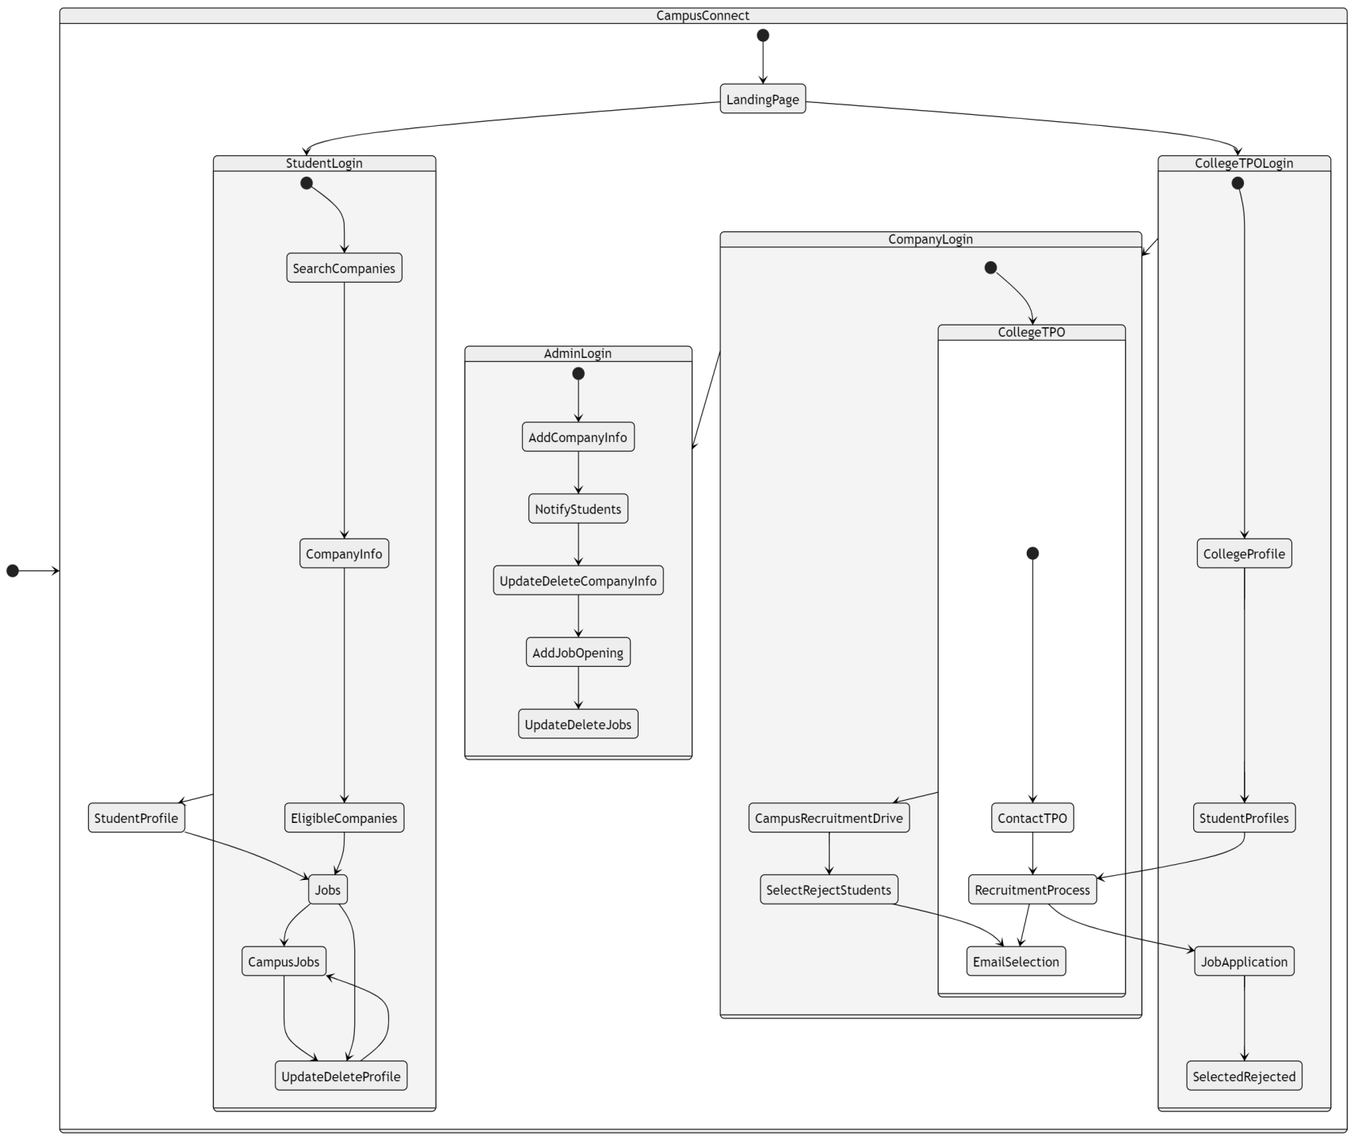

#### Figure 4.1: System Architecture

System architecture is the total view of system flow.

Direct input of data and get output

##### Landing Page:

User can directly enter their details such as 12th marks their CGPA and total number of backlogs then system shows in which companies they can approach for placement. It is very helpful for student to get their career page link at same time on website. In this working all result of companies are came from the database in which all information are present already.

On the other hand, TPOs have their own secure login, allowing them to view student profiles and see which companies have shortlisted each student. This dual-access system ensures that both students and TPOs have the necessary tools to efficiently manage the placement process. The database is the backbone of the system, maintaining comprehensive records of both student data and company criteria to ensure accurate and effective matching.

## 4.2 Flowchart

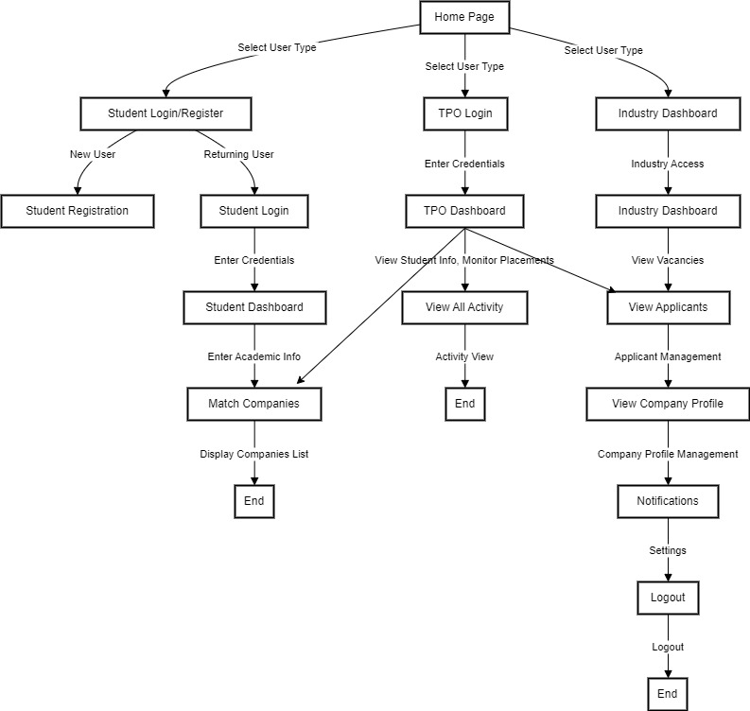

#### Figure 4.2: Flowchart

Flowchart is a graphical diagram that represents the sequence of steps to solve a problem. A flowchart is a diagrammatic representation of an algorithm. In computer programming, the flowchart diagram helps to write down an algorithm to solve the problem.

It was originated from computer science as a tool for representing algorithms and programming logic but had extended to use in all other kinds of processes. Nowadays, flowcharts play an extremely important role in displaying information and assisting reasoning. They help us visualize complex processes, or make explicit the structure of problems and tasks. A flowchart can also be used to define a process or project to be implemented.

The flowchart outlines the interactive journey for students, Training & Placement Officers (TPOs), and industries within the placement ecosystem. Starting at the Home Page, users choose their role: students proceed to either register or login, TPOs access their dedicated dashboard, and industries directly enter their dashboard. Once logged in, students navigate to their dashboard to provide academic information, match with companies, and access career opportunities. TPOs monitor placement activities and view comprehensive activity logs. Industries manage vacancies, applicants, and profile details. The flowchart ensures a seamless interaction, guiding users through registration, authentication, and access to relevant features, fostering efficient placement management.

## Entity Relation Diagram

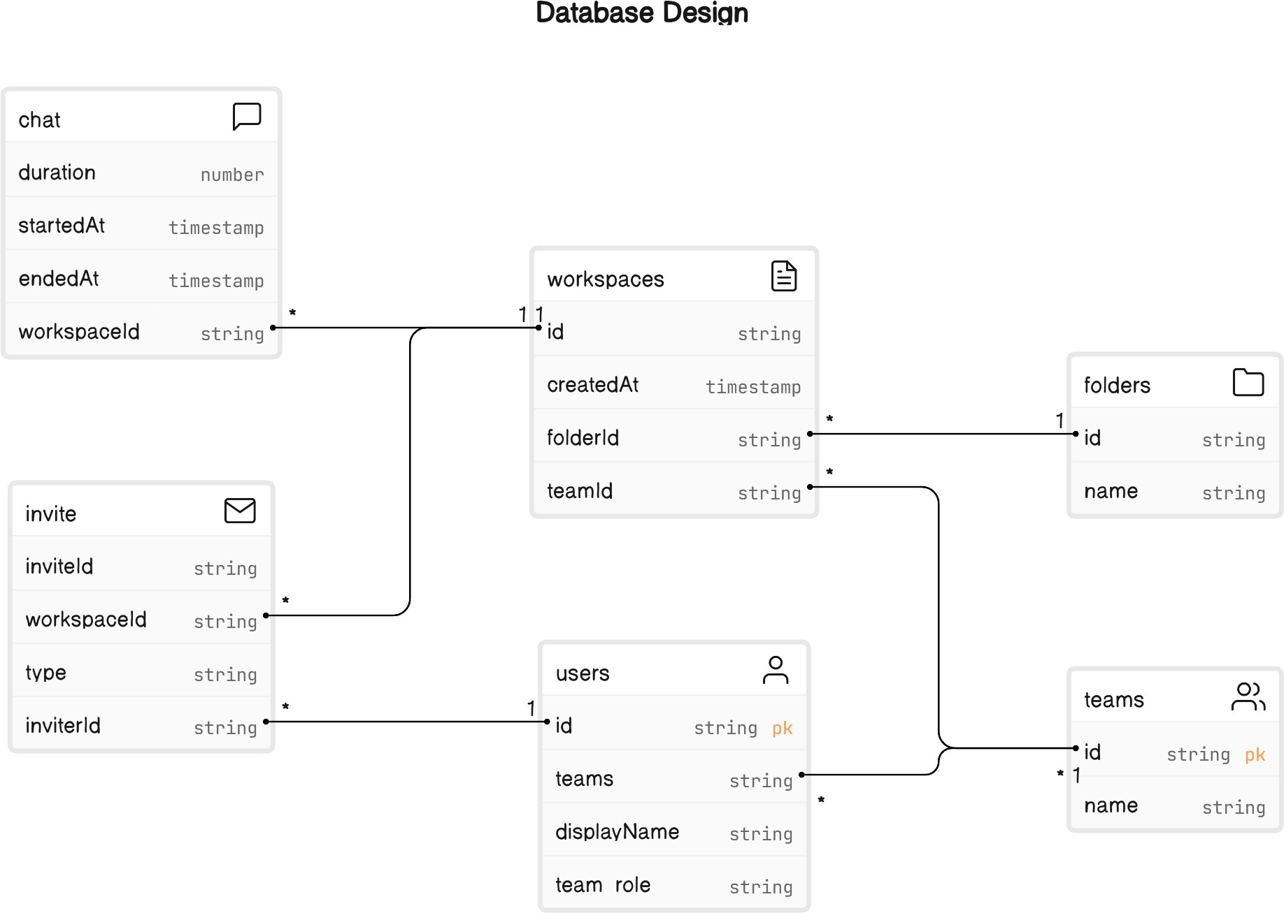

#### Fig 4.3: Entity Relationship Diagram

Entity-Relationship Diagrams (ERDs) depict database structures, illustrating entities, attributes, and relationships. Entities represent real-world objects, attributes describe properties, and relationships define connections. ERDs aid in visualizing and designing databases, ensuring data integrity and efficient information retrieval in software engineering and database management.

## Sequence Diagram

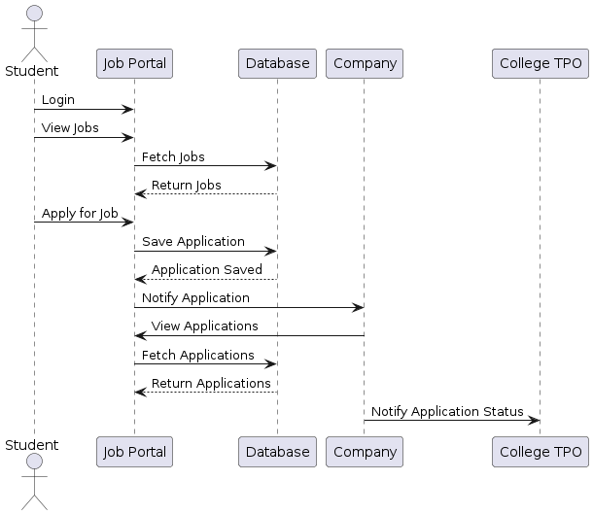

#### Figure 4.4: Sequence Diagram

Sequence diagrams in UML show how objects interact with each other and the order thoseinteractions occur. It’s important to note that they show the interactions for a particular scenario. The processes are represented vertically and interactions are shown as arrows. This article explainsthe purpose and the basics of Sequence diagram.

A sequence diagram is an interaction diagram. From the name, it is clear that the diagramdeals with some sequences, which are the sequence of messages flowing from one object to another. Interaction among the components of a system is very important from implementation and execution perspective. Sequence diagram is used to visualize the sequence of calls in a system toperform a specific functionality.

## 4.6 Class Diagram

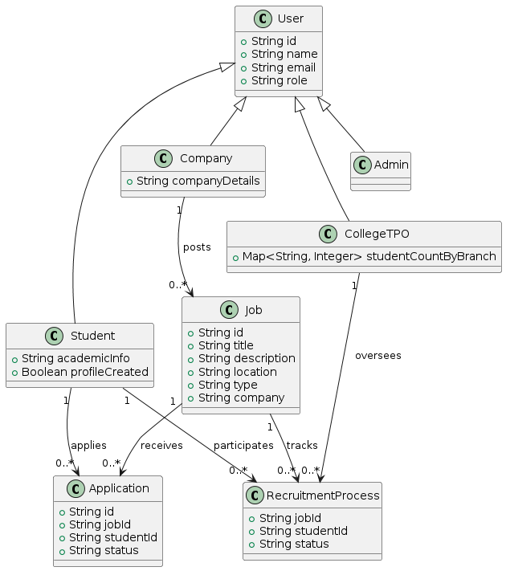

#### Figure 4.5: Class Diagram

Class diagrams are the main building block of any object-oriented solution. It shows the classes in a system, attributes, and operations of each class and the relationship between each class.

In most modeling tools, a class has three parts. Name at the top, attributes in the middle and operations or methods at the bottom. In a large system with many related classes, classes are grouped together to create class diagrams. Different relationships between classes are shown by different types of arrows. Class diagram consists of classes, interfaces, associations, and collaboration. Class diagrams basically represent the object-oriented view of a system, which is static in nature.

## Use Case Diagram

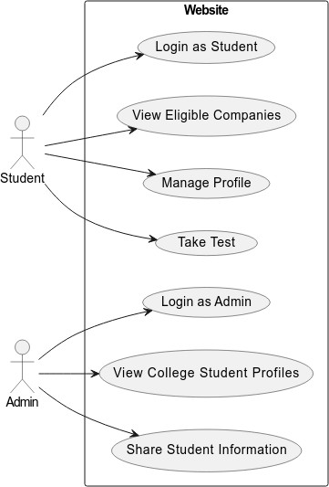

#### Figure 4.6: Use Case Diagram

A use case diagram is a representation of a user’s interaction with the system and showsthe relationship between the user and the different use cases. In above fig. our system represents the interaction between user and system.

## Activity Diagram

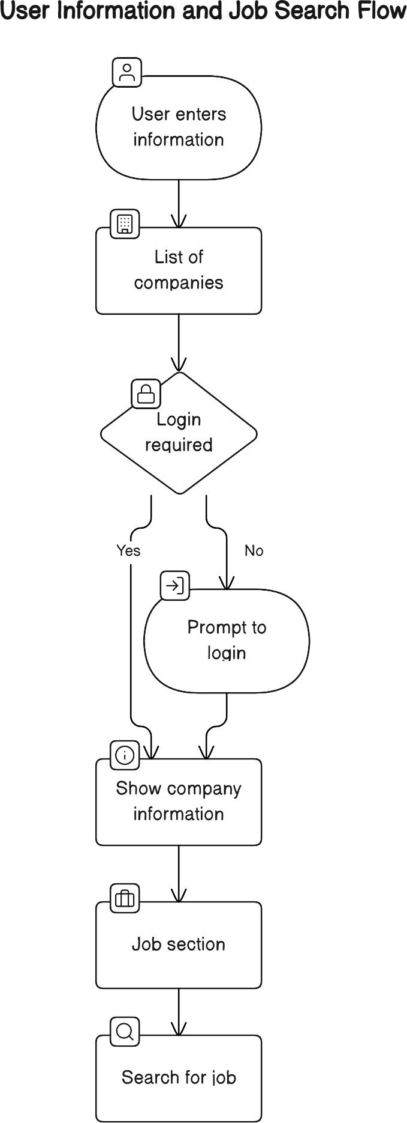

#### Figure: 4.7 Activity Diagram

Activity diagram focuses on the execution and flow of the behavior of a system instead of implementation. Above fig represents the actual flow of and behavior of our system. It consist of that are made up of action which apply to behavioral modeling technology.

## Component Diagram

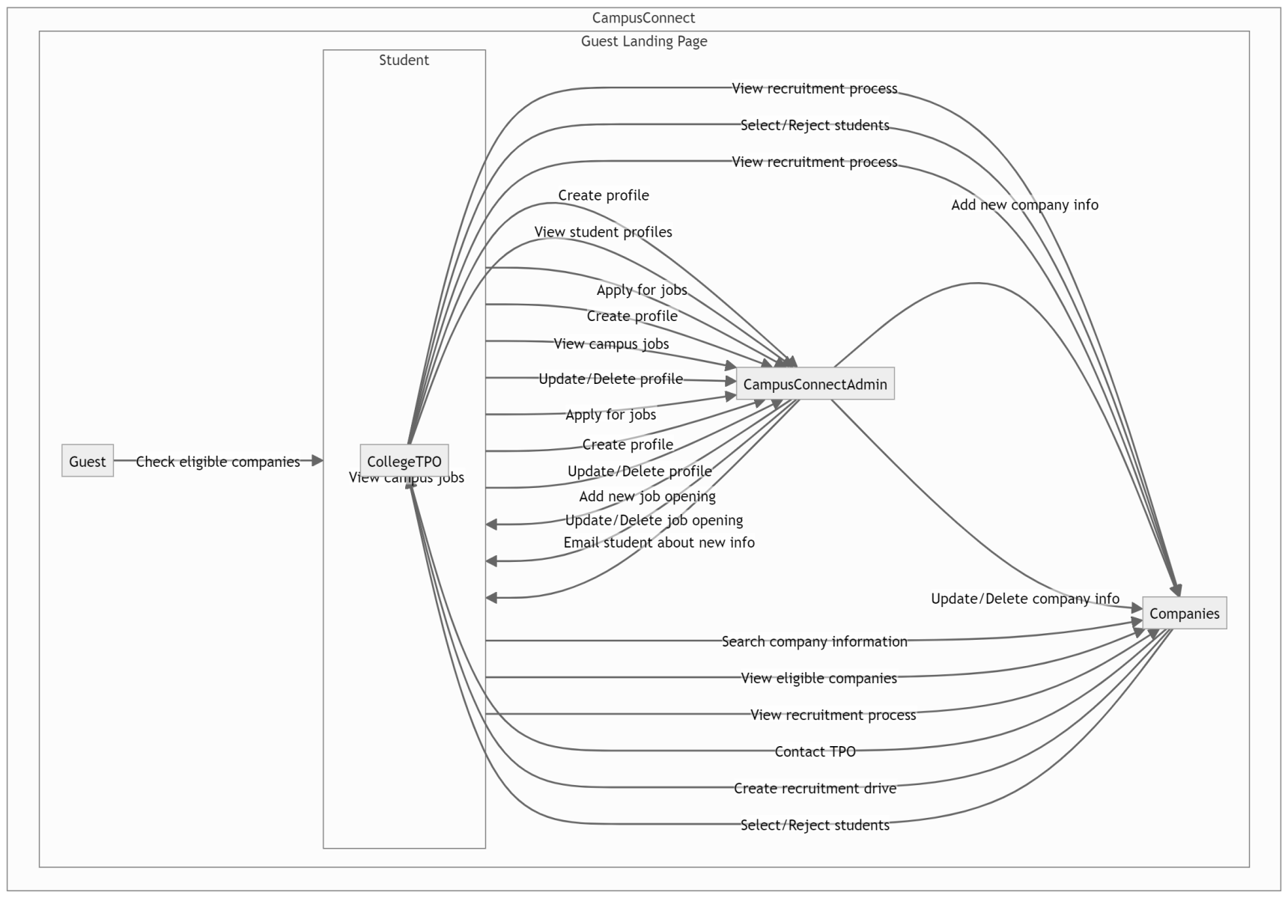

#### Figure 4.8 Component Diagram

This component diagram shows the all different component present in website as above. This is component diagram of campus connect site which shows component provided and requirement interfaces parts and relationship between the different parts of website as main page profile making of site, searching company.

## Programming Language Used

**Front End**: -

* + HTML
  + CSS
  + JavaScript
  + React.js

##### Back End:-

* + - Node.js
    - Express.js
    - MongoDB(Database)

# Chapter 5 RESULTS AND CONCLUSION

## RESULT

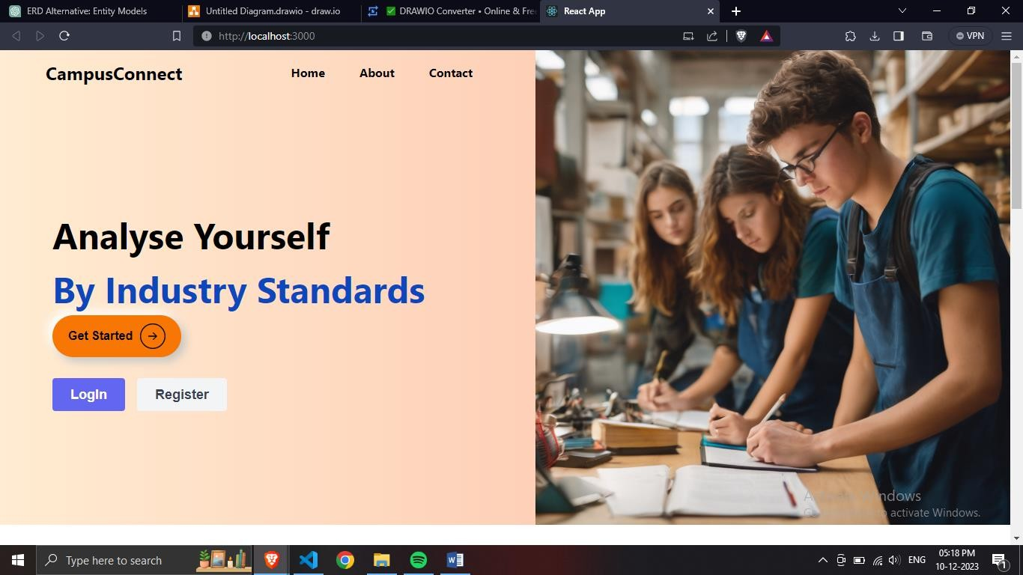

#### Fig. 5.1 Landing Page

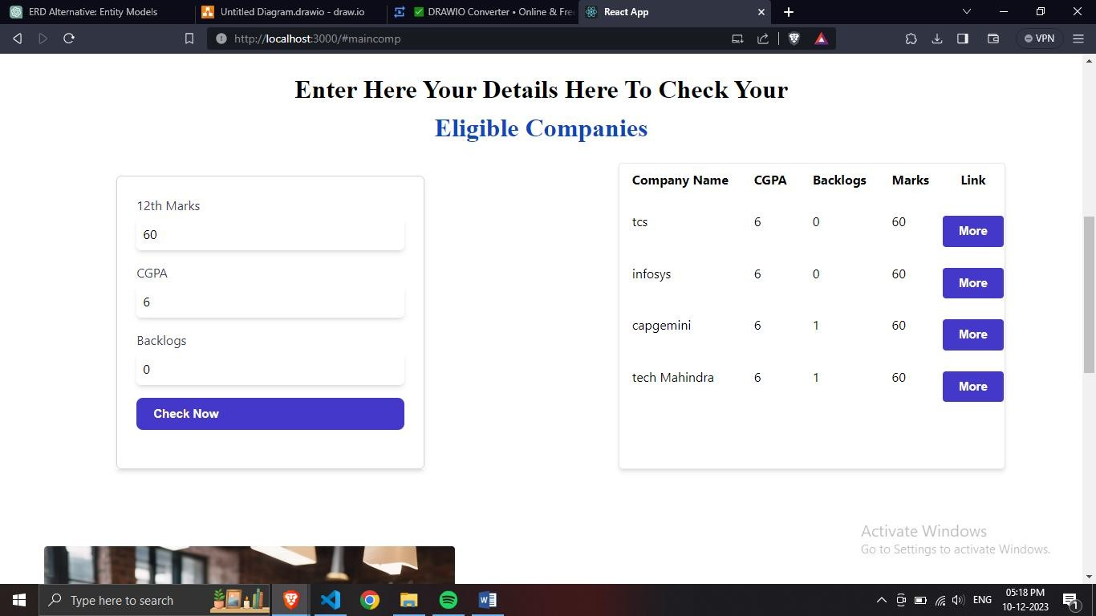

Figure 5.2: List of Companies

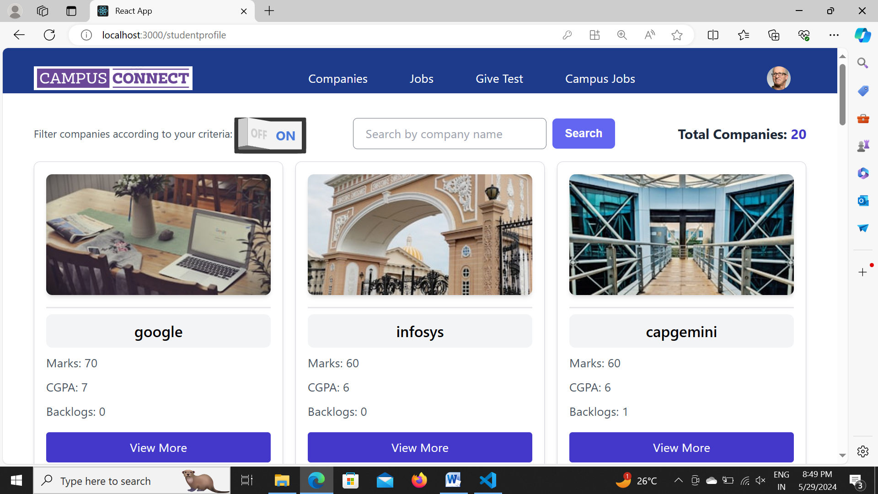

#### Figure 5.3: Profile with result

This is output of project. Website can successfully identifies the different companies according to

the student or user criteria’s such as 12th marks, their CGPA and also the total number of backlogs in their academic year. Once a user make their profile on our website its shows the accurate result of companies to they can approach for placement.

Additionally, the platform includes an admin panel where Training and Placement Officers (TPOs) can view the list of companies shortlisted for each student. Companies can also use the admin panel to add their job vacancies, ensuring a streamlined and efficient placement process for all parties involved.

## CONCLUSION

The project entitled as CampusConnect is the system that deals with the issues related to Students and their Placements.

This project is successfully implemented with all the features mentioned in system requirements specification.

The application provides appropriate information to users according to the chosen service.

The project is designed keeping in view the day to day problems faced by a student and job seekers. Automation of the entire system improves the efficiency.

It provides a friendly graphical user interface which proves to be better when compared to the existing system.

Website are able to give the list of companies when user enter their details in form and also it give permanent list of companies with their career page link to our website also. This is very helpful to students and also working professionals to identify their place of work effectively.

## FUTURE SCOPE

.

* It will help a person who are actually working and looking for better opportunities and work culture.
* It reduce much time to find out the companies in which user can apply.
* The website would predict student chances to get placed in particular company.
* All TOP work should get done in this site.
* Create an alumni network feature where former students can offer mentorship, job referrals, and networking opportunities to current students.
* Extend the platform to include internship and apprenticeship opportunities, providing students with more entry-level positions and hands-on experience.
* Integrate with professional networking sites like LinkedIn to allow seamless profile updates and job application processes.

# Chapter 6 REFERENCES

## REFERENCES

1. Sonal Kureshi The IUP journal of marketing management, Vol.9 Nos 1& 2 2010-05-26
2. Vandana Sood Conceptual and Managerial implication “The usage placements is increasing across media making it essential for us to understand its effect on the audience”. 2010
3. Nilesh Rathod As Interactive online Training and Placement system “College talent placement system at providing the facility to automate and simplify the process of registration and list generation of eligible students for placement”. 2013
4. Shilpa Hadkar College collaboration portal with training and placement “The project will indicate manual work and maximize optimization, abstraction and security. Students will get notify when TPO’s upload study material or any campus drive information through the system”. 2014
5. Rampalli Paya, Ganesan Palanisamy, S.K.V Jayakumar Mediterranean journal of social “Campus recruitment is the process by which the corporate recruit students who are about to graduate from the educational institution”. 2015.
6. Suraj Gupta “Recruitment system with system prediction “This concept is used to determine in next step to determine or predict employee placement based on their characteristics” 2021.